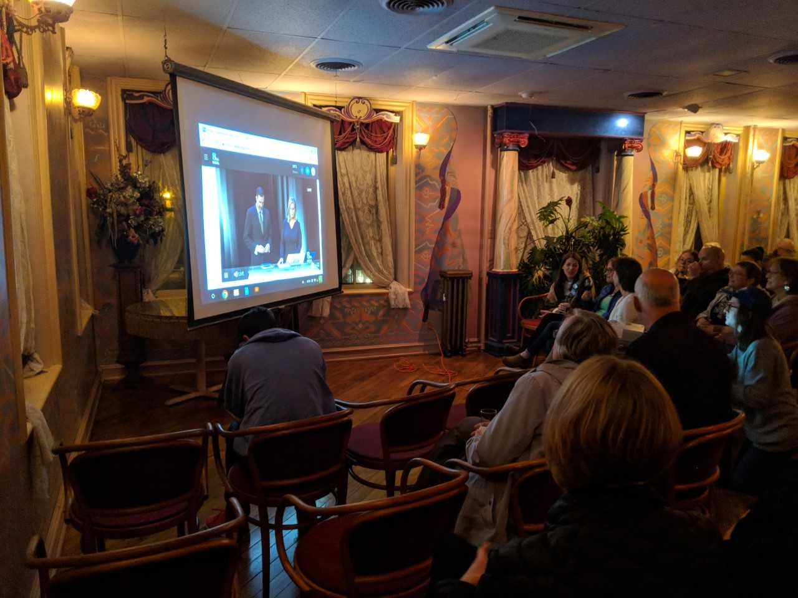
Blue Voters Tread Red Water
By Blair Martin
Nov. 6, 2018

Mt. Joy, PA - Democrats remain hopeful in PA’s district 11 as the midterms draw near.
On Tuesday a debate watch party, hosted by organizers with the Jess King campaign, was held at Bube’s Brewery, Mt. Joy, Pennsylvania. The event began at 6:30 p.m. and the debate started promptly at 7 p.m.
This third debate, between the democratic challenger, Jess King, and the republican incumbent, Lloyd Smucker, covered multiple issues from health care and Medicare to immigration and the wall.
A small audience of around 30 people gathered in an upstairs bar of the restaurant. The group sat around a small projector displaying the debate from the WGAL news website.
As the candidates talked through the issues, the audience followed along with sighs, groans, cheers and, at times, “amen.”
Smucker, on the issue of racial equality, referred to the district as a “welcoming community,” a phase Phyllis Macdonald laughed at.
“Well, I mean, historically, Lancaster County is not known as a welcoming community, because of its conservative nature. And he’s one of the least welcoming people I have known,” said MacDonald.
The debate continued. Both candidates were given a chance to discuss their views on issues such as tariffs, gun violence, and the opioid crisis. The audience followed along attentively, listening to what both candidates had to say.
In a discussion afterwards, members of the audience were asked what they thought of King’s performance. They appreciated King’s direct approach to the moderators’ questions and were excited to be voting for her on the sixth.
Liam Schaffer shared their sentiment. A paid canvasser, he had only been working for the campaign for a week but was encouraged by King’s performance in the debate.
“I mean, I think it went really well. Jess is always good at speaking. She knows where she stands. She knows what she wants for the American people and she knows how to communicate that. I think she did really well,” he said.
The democrats and the small collection of moderate republicans have reason to feel energized. According to ABC27, King is currently only four points behind Smucker, within the margin of error in what was determined to be a solid red district.
The close race is made even more surprising by the effect that Pennsylvania’s new district map will have on current election outcomes, particularly the new district 11.
In an article from the New York Times, newly drawn districts were compared to the ones from the previous map. In the previous map, the Republican Party had an advantage over the democrats statewide.
The district that Smucker represents voted for trump by seven points. Now, with a redrawn district map, though republicans no longer have an advantage, voters in the new district 11 would have voted for Trump by 26 points.
“We’re definitely the underdog in the race, but I think the polling shows that what we’re doing here is working: talking to people just one on one,” said Sierra Brennan, a youth organizer with the Jess King campaign.

Sources:
https://www.abc27.com/news/politics/election/poll-us-rep-smucker-holds-narrow-lead-over-democrat-king/1562382601
https://www.nytimes.com/interactive/2018/02/19/upshot/pennsylvania-new-house-districts-gerrymandering.html
Phyllis Macdonald
Sierra Brennan
Liam Schaeffer

Blair Martin
October 3, 2019
Mr. Martin goes to Washington
The title is a bit of humor to break the ice. The truth is that I’m not very good at introductions; I never know how to open a conversation. Common sense tells me to start on a more professional note, but at the same time, I find it’s important to write with personality. Does that put me at a disadvantage? Maybe. But on the bright side, I’m myself, and now for the suit and tie.
During high school I was mostly a music student. But when choosing a college major, I knew I should pick something that was a bit more lucrative if I wanted to be successful. Aside from band and choir, the classes I enjoyed the most were German and AP Gov. I wasn’t the best in those either, but they were the classes I looked forward to the most. Even they didn’t have a broad enough career outlook for me. Instead, I settled on journalism with a minor in political science, a major with a promising career field which I can use to explore my other interests.
By applying to this program, I hope to gain a better understanding of my major and explore the abundant job opportunities that it offers. While at Penn State Harrisburg, I spent the majority of my free time working. Internships were not an option considering my financial situation. Now that I’m at University Park, I’m looking for any chance I can find to get the experience I need to be successful in my field.
The experience should hopefully educate me on what it takes to work in media and what employers look for in a potential employee. The experience, as mentioned during an information session I attended, should also help me identify the path that works best for me, whether that’s in the private sector with a media organization or in the public sector to pursue a job more becoming of my minor.
While my current experience is lackluster, I think that I make up for it through my personality. I’m not one to boast my own talents, but this is an application essay after all. Personally, I find that I can be very approachable and easy to talk to. Those who know me would say I’m very kind and friendly. I’m not a very intimidating person. I work well both by myself and in a team. I welcome instruction and encourage my superiors to tell me how I can improve. I’m very self-motivated as I am the first person in my family to attend college. I’m eager; I look forward to any opportunity that this program may offer me.
On the topic of opportunity, seeing as that the program is located in Washington D.C., I should detail what internships are interest to me. I’m not asking for much, I don’t need to start off big. When it comes to internships, anything under the sun would be appropriate. As a Broadcast Journalism major, internships that would be most beneficial to me would ones at any of the numerous media organizations in the area. The bulk of what little media experience I have lies in radio production and editing. I am familiar with both Logic Pro and Adobe Audition. I will, however, be open and receptive to a position in print or TV news as well. I’m not picky.
In regard to my political science minor, the same philosophy applies. I am very flexible and can adapt to any work environment I find myself in. My main area of interest in political science is in foreign relations. Since I was 13 my family has regularly hosted exchange students from Europe. I’ve met and hosted students from Spain, France, and Germany, and getting to intern where I can better explore America’s foreign relations would be a dream come true.
To be honest, any internship in D.C. would be a dream come true, whether it’s in media, pursuing breaking stories and informing the public, or with the government. The Washington D.C. program will be a steppingstone for me. With it, I can explore and better understand what a future in my current area of study will look like. I’ll be able to see if where I am is where I’d like to end up. I’m not certain of what career is best for me, but if the program accepts me, I’ll take advantage of the opportunity and use that time and experience to understand where I best fit in. Thank you.

