
Getting Started with LionPATH
LionPATH is the student information system that allows you to accept financial aid, enroll in classes, pay your bill, and much more.
Note: The first time you access LionPATH you will provide your consent to do business electronically. This consent will be required annually.

LionPATH Student Center
The LionPATH Student Center provides you easy access to the information you will use regularly. The information is grouped into logical sections and can be easily accessed using links and drop-down lists.
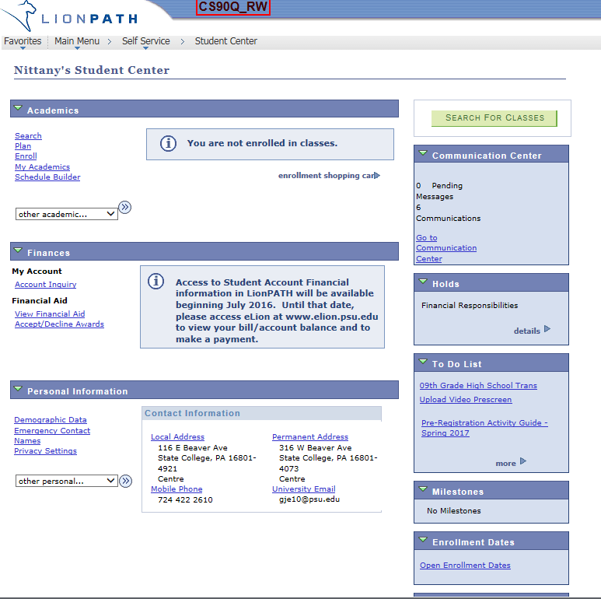
Figure 1: Student Center

Academics
The Academics section contains information related to enrollment and scheduling. Once you have enrolled in classes, your class schedule will be displayed in this section.

Finances
The Finances section contains information related to your account balance and financial aid. This includes the ability to view, accept, and decline financial aid.

Personal Information
The Personal Information section contains your name, email, phone and address information. In addition, your emergency contact information is available and can be updated using this section.

LionPATH Student Center: Quick Reference Boxes
The Quick Reference Boxes on the right contain items such as communication, holds, to do lists, milestones, enrollment dates, and advisor information.

Communication Center
The Communication Center box will display student communication from various offices. If communications are displayed, click the Go to Communication Center link at the bottom, for more information.

Holds
The Holds box lists holds (financial, academic, etc.) that have been placed on your record to restrict services. If holds are displayed, click the details link in the lower right corner, for more information. The details of the hold contain the start and end terms/dates of the hold. If you need additional information regarding the hold, clicking on the Hold Item name will provide you with the appropriate contact information.

To Do List
The To Do List contains items that you need to complete. Be sure to check this area frequently, as items placed here could impact your ability to complete other tasks.
Note: The To Do List box will also be used to notify you of the receipt of FAFSA information.
Prior to each semester’s enrollment, a Pre-Registration Activity Guide will appear in your To Do List. It contains a Financial Responsibility Agreement as well as Emergency Contact information, both of which are required to be completed each semester. Completing this activity guide will release the Financial Responsibility hold and allow you to enroll during your enrollment window.

Milestones
The Milestones box is used to indicate non-course requirements such as certifications.

Enrollment Dates
The Enrollment Dates box contains the first day you can enroll in classes for the coming term.

Advisors
Your assigned advisor(s) will be listed in the Advisor box, clicking on their name will provide additional information.

