Emma Daubert
23 Cassandra Drive Perkasie, PA 18944 | 717-250-2025 | ecd5224@psu.edu
14 October 2018
Catie Grant
Director
CommAgency
Donald P. Bellisario College of Communications
Dear Catie Grant:
I am writing to express my interest in the position at CommAgency for the spring semester. I learned about this opportunity through Bob Martin and as I read more I became intruiged. I also got a chance to sit down with Christina Chambers at my Scholarship Recipient Dinner and learn more about this program. I am a Journalism major who has an interest of venturing into Broadcast Journalism and feel as though this opportunity would serve me well. I am very interested in video production and the hands-on experience you are offering is second to none.
In high school I was able to take a Broadcast Journalism course which exposed me to this wonderful field. I was able to create, film, and edit my own videos throughout the course of the year. I feel as though my prior knowledge could be helpful in CommAgency. However, I know CommAgency will teach me so much more than I already know, and I really hope I have that opportunity. My creative and hardworking mindset is perfect for this position.
I hope to hear back from you soon. It would be my pleasure to be a part of the CommAgency community and make incredible videos for our University. I look forward to your response and hope to meet you soon.
Sincerely,
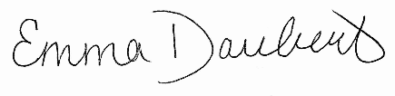
Emma Daubert

